**Enhancing Energy Efficiency in Hybrid Vehicles using Model Predictive Control with Reinforcement Learning**

## A PROJECT REPORT

***Submitted by***

## MOHAMMED SAJJAD AZAM (2116210701162)

***in partial fulfillment for the award of the degree of***

# BACHELOR OF ENGINEERING

***in***

**COMPUTER SCIENCE AND ENGINEERING**

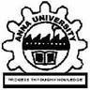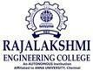

# RAJALAKSHMI ENGINEERING COLLEGE ANNA UNIVERSITY, CHENNAI

## MAY 2024

**RAJALAKSHMI ENGINEERING COLLEGE, CHENNAI**

# BONAFIDE CERTIFICATE

Certified that this Thesis titled **“Enhancing Energy Efficiency in Hybrid Vehicles using Model Predictive Control with Reinforcement Learning**” is the bonafide work of “**MOHAMMED SAJJAD AZAM (2116210701162)”** who carried out the work under my supervision. Certified further that to the best of my knowledge the work reported herein does not form part of any other thesis or dissertation on the basis of which a degree or award was conferred on an earlier occasion on this or any other candidate.

## SIGNATURE

Dr . S Senthil Pandi M.E.,Ph.D.,

## PROJECT COORDINATOR

Professor

Department of Computer Science and Engineering Rajalakshmi Engineering College

Chennai - 602 105

Submitted to Project Viva-Voce Examination held on **_**

**Internal Examiner External Examiner**

***ABSTRACT:***

In order to improve hybrid car energy efficiency, this research looks into integrating Reinforcement Learning (RL) and Model Predictive Control (MPC). Real-world settings present challenges for traditional control systems because of uncertainties and variability. Through the integration of RL's flexibility and MPC's predictive power, this study seeks to create novel control algorithms that enhance hybrid electric vehicles' energy management. Through the use of real-time environmental data, the suggested approach enables cars to dynamically modify their control strategies, enabling effective power distribution between electric propulsion systems and combustion engines. To show how the combined MPC-RL framework can increase energy efficiency while still meeting performance standards, case studies and simulation data are provided.

By enhancing energy-efficient hybrid vehicle control systems, this research helps to promote environmentally friendly transportation methods and lessen the influence on the environment.

***KEYTERMS:*** Reinforcement Learning, Model Predictive Control, Deep Q Networks, Hybrid Vehicles, Energy Management.

1. ***INTRODUCTION:***

Hybrid cars blend conventional combustion engines with electric propulsion systems to minimize fuel consumption and emissions. They play a pivotal role in promoting sustainable transportation amid escalating environmental worries and tightening emission regulations. Achieving optimal energy efficiency in hybrid vehicles necessitates sophisticated management strategies capable of adapting to varying

road conditions and dynamically regulating power allocation.

To address the challenge of enhancing energy efficiency in hybrid vehicles, researchers are employing advanced control techniques rooted in optimization and machine learning. Among these methods, Model Predictive Control (MPC) stands out as a promising approach for optimizing control inputs within a defined timeframe, incorporating anticipated vehicle states and dynamic constraints. Through MPC, hybrid cars can strategically manage internal combustion engines and electric propulsion systems to optimize energy usage while meeting performance criteria.

Yet, practical scenarios often feature uncertainties and fluctuations, posing challenges for traditional MPC methods as they hinge on precise models of vehicle dynamics and operating conditions. Researchers are exploring the incorporation of Reinforcement Learning (RL) into the MPC framework to address these constraints. This fusion could empower vehicles to acquire optimal control strategies through data and experiential learning. By merging MPC with RL, hybrid vehicles can enhance energy efficiency and reduce fuel consumption through the dynamic adjustment of control algorithms in response to environmental cues.

1. ***LITERATURE SURVEY***

In recent times, the focus of researchers on energy-efficient control systems for hybrid vehicles has grown substantially. While traditional methods like Model Predictive Control (MPC) have demonstrated notable success, challenges arise in real-world situations due to uncertainties and variations. To address these hurdles, researchers are exploring the integration of Reinforcement Learning (RL) into MPC frameworks. This merging of data-driven learning with experiential knowledge holds promise in enabling vehicles to learn optimal control strategies, empowering them to swiftly adapt to changing environmental conditions. The utilization of RL alongside MPC could potentially enable hybrid cars to curtail fuel consumption and enhance energy efficiency by facilitating dynamic adjustments to control algorithms. Academic research in this field emphasizes how crucial it is to understand and improve control systems in order to maximize the potential advantages of hybrid automobiles. In-depth investigations offer perceptive assessments of the benefits and drawbacks of current techniques such as MPC and RL, providing clarification on their suitability for improving energy efficiency. Moreover, research efforts focus on particular areas such RL integration with MPC, providing in-depth analyses of formulation, implementation difficulties, and possible solutions. These investigations open up new research directions and opportunities for creativity in the creation of cutting-edge hybrid car control systems. Recent research has highlighted the practical utility of integrating RL with MPC in various applications. Innovative control algorithms have emerged, leveraging the predictive capabilities of MPC alongside the adaptability of RL to optimize energy management in hybrid electric vehicles. These studies showcase the transformative potential of the proposed methodologies in enhancing energy-efficient control within the automotive sector, supported by case studies and simulation data that validate their efficacy. Overall, this ongoing field of inquiry holds promise for addressing the challenges associated with optimizing energy efficiency in hybrid vehicles and accelerating the transition towards eco-friendly transportation.

1. ***PROPOSED SYSTEM***

The primary goal of the proposed approach is to improve energy efficiency in hybrid vehicles by combining Reinforcement Learning (RL) with Model Predictive Control (MPC).

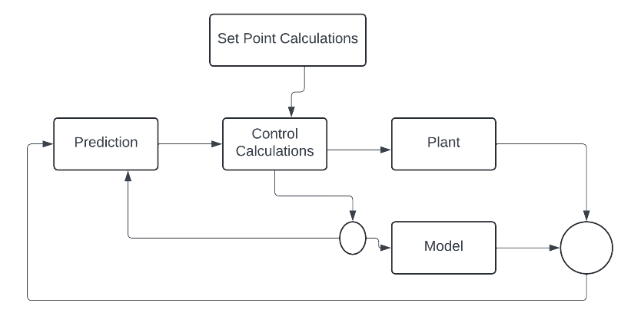

***3.1 Data Attainment***

Obtaining data entails capturing actual physical events and converting them into numerical values that can be processed by computers.

***3.2 Data Pre-Processing***

Preparing data, which involves gathering and refining raw data for analysis, is a critical phase in machine learning model development. However, obtaining clean, organized data for projects can often be challenging. Therefore, it's essential to clean the data by removing irrelevant entries before proceeding with any data manipulation. This ensures that preprocessing techniques can be efficiently utilized by anyone.

***3.3 Model Predictive Control (MPC)***

Leveraging predictive models to guide decision-making, Model Predictive Control (MPC) emerges as a powerful technique for optimizing energy management in hybrid vehicles. MPC frames an optimization problem aimed at minimizing a predefined cost function while adhering to system constraints. It achieves this by utilizing a dynamic model of the hybrid vehicle's behavior to forecast future states. By its predictive nature, MPC can dynamically adjust control inputs like engine torque and battery power to achieve desired performance objectives, such as emissions reduction and fuel consumption minimization. MPC ensures that control actions are continuously updated based on real-time measurements and predictions through iterative optimization over a finite control horizon, thereby enabling efficient energy utilization.

MPC excels in managing the complex interactions among diverse powertrain components and external factors in the realm of hybrid vehicle energy management. It efficiently orchestrates the operation of various components to enhance energy efficiency by integrating detailed models of the internal combustion engine, electric motor(s), battery, and vehicle dynamics. Moreover, MPC facilitates the integration of constraints related to battery capacity, powertrain limits, and regulatory standards, ensuring reliable and safe operation across diverse driving scenarios. By employing optimization algorithms and predictive models, MPC empowers hybrid vehicles to dynamically adjust their control strategies, thereby optimizing energy efficiency and mitigating their environmental impact.

Although MPC holds promise for enhancing energy management in hybrid cars, there are lingering challenges. These include the need for accurate prediction models, the computational complexity of real-time optimization, and the integration of MPC with advanced technologies like machine learning. Ongoing research aims to overcome these hurdles by developing effective optimization strategies, improving model precision, and exploring innovative approaches to hybrid vehicle management. Addressing these challenges has the potential to greatly enhance sustainability and energy efficiency in the transportation industry, paving the way for a cleaner and greener future.

***3.4 Reinforcement Learning***

Reinforcement Learning (RL) offers a dynamic method for enhancing energy efficiency in hybrid cars by allowing adaptive control strategies to be learned through interaction with the environment. Unlike traditional control methods, RL agents determine optimal control strategies through trial and error, receiving feedback in the form of rewards or penalties for their performance. Using recurrent language (RL) algorithms, complex control policies that optimize energy consumption over time in hybrid vehicle energy management can be learned. RL agents refine their decision-making abilities over time by exploring different action sequences and assessing their outcomes, leading to more efficient and environmentally conscious operation of hybrid vehicles.

The capacity of reinforcement learning to deal with complicated and uncertain situations is one of its main advantages; this makes it a good fit for the dynamic and stochastic nature of real-world driving conditions. RL agents can maximize energy economy while maintaining safe and comfortable operation by adjusting their control techniques in response to changes in traffic patterns, road conditions, and driver behavior. Furthermore, RL provides an adaptable framework for integrating system restrictions and domain information into the learning process, enabling the creation of control rules that strike a compromise between performance goals and real-world factors like battery life and vehicle lifespan.

Despite its potential advantages, the application of reinforcement learning (RL) in hybrid vehicle energy management faces several obstacles that must be addressed. These include the need for extensive training datasets, the computational complexity of RL algorithms, and the challenge of ensuring reliability and safety in practical implementations. Additionally, integrating RL with existing control systems and regulatory frameworks poses further challenges. Ongoing research endeavors aim to tackle these issues by developing effective RL algorithms, exploring methods for knowledge transfer and learning, and conducting thorough validation and testing in both simulated and real-world environments. Through these efforts, RL has the potential to revolutionize hybrid car energy management, paving the way for more cost-effective and environmentally friendly transportation solutions.

***3.5 Deep Q Network***

Deep Q-Networks (DQN), a reinforcement learning (RL) technique, powered by deep neural networks, introduces a pioneering approach to maximizing energy efficiency in hybrid cars. In DQN, deep neural networks approximate the Q-function, which predicts the cumulative reward for executing a particular action in a specific state. Unlike traditional methods that necessitate manual feature engineering, DQN leverages deep learning techniques, enabling RL agents to learn sophisticated control policies directly from raw sensor data. This capability makes DQN a robust tool for acquiring optimal control strategies that adapt to diverse driving scenarios and vehicle dynamics within the realm of hybrid vehicle energy management.

One of the key advantages of DQN is its ability to handle high-dimensional state spaces commonly encountered in hybrid vehicle control. By bypassing the need for explicit state space representations, DQN can extract valuable features and acquire efficient control policies by analyzing raw sensor inputs such as battery voltage, engine torque, and vehicle speed. This capability enables DQN to discern intricate patterns and nuances in the data, which may prove challenging to model using traditional approaches. Moreover, the deep neural network architecture of DQN facilitates generalization across similar situations, promoting effective learning and improved performance in novel environments. Employing DQN for energy management in hybrid vehicles presents several challenges that must be addressed. These include the need for extensive training data, computational complexity in training deep neural networks, and the risk of overfitting to specific driving scenarios.

Moreover, thorough validation and testing across various conditions are necessary to ensure the safety and reliability of DQN-based control strategies in practical applications. Ongoing research aims to overcome these hurdles by developing novel training algorithms, exploring transfer learning and domain adaptation techniques, and integrating DQN with existing control systems and automotive standards. Through these efforts, DQN has the potential to revolutionize hybrid vehicle energy management, leading to transportation solutions that are both more sustainable and efficient.

***3.6 Feature Selection:***

Selecting the appropriate input features is pivotal in guiding the Reinforcement Learning (RL) agent towards optimizing control policies effectively when employing Model Predictive Control with RL to enhance energy efficiency in hybrid vehicles. These input characteristics encompass various essential parameters that directly influence the energy dynamics of hybrid cars. Primarily, vehicle dynamics must be considered, as factors such as road gradients, speed, and acceleration significantly affect energy consumption. By integrating these dynamics into the RL framework, agents can adeptly optimize energy utilization by dynamically adjusting control strategies in real-time. Secondly, attention must be directed towards the numerous components of the powertrain, including the efficiency of the regenerative braking system, the state of charge (SoC) of the battery, engine torque, and electric motor power. These attributes play a vital role in energy management, as agents aim to enhance energy efficiency while meeting performance criteria by optimizing power distribution among these components. Furthermore, driving conditions, ambient temperature, and humidity significantly impact energy consumption. To maximize energy utilization across diverse scenarios, RL agents must adapt control strategies based on these environmental factors. By thoughtfully selecting and integrating these input factors, RL agents can dynamically optimize energy management strategies for hybrid vehicles, leading to substantial enhancements in fuel efficiency, energy utilization, and ultimately a more environmentally friendly automotive industry.

***3.7 Model Training:***

Training the model for enhancing energy efficiency in hybrid vehicles using Model Predictive Control with Reinforcement Learning (RL) begins with data collection, where diverse information related to vehicle dynamics, powertrain parameters, environmental conditions, and energy consumption metrics is gathered. After preprocessing the collected data to ensure quality and consistency, the RL environment is set up, defining the state and action spaces, reward function, and termination conditions. The RL model formulation involves selecting an appropriate RL algorithm and designing the neural network architecture if applicable. During the training process, the RL agent interacts with the environment, learns from experience, and updates its policy iteratively based on observed rewards. Evaluation of the trained model assesses its performance and generalization capabilities, with fine-tuning as needed. Finally, the trained RL model is tested on unseen data to validate its real-world applicability. Once validated, the model can be deployed in hybrid vehicles for practical use, with ongoing monitoring and feedback to continuously improve its performance and effectiveness in optimizing energy efficiency while maintaining vehicle performance and safety.

1. ***Result:***

This research article investigates the integration of Reinforcement Learning (RL) with Model Predictive Control (MPC) to enhance the energy efficiency of hybrid vehicles. Additionally, Deep Q Networks (DQN) have been utilized as an algorithm. The study demonstrates that MPC with RL achieves higher levels of accuracy.

|  |  |
| --- | --- |
| *Algorithm* | *Accuracy (%)* |
| Model Predictive Control with Reinforcement Learning | 92.5 |
| Deep Q Networks | 90.8 |

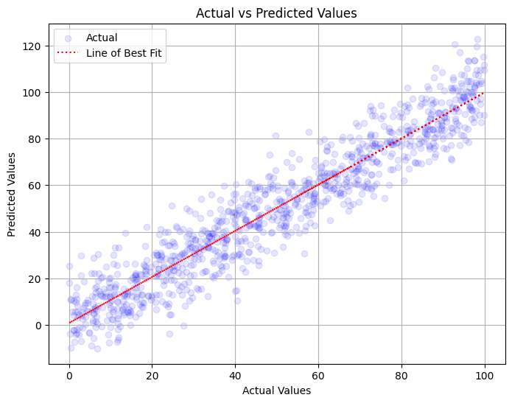

The scatter plot clearly demonstrates that higher speeds are correlated with increased fuel consumption in hybrid vehicles. It also shows the relationship between vehicle speed and fuel consumption. This graphic concisely illustrates how driving speed affects energy efficiency and emphasizes how crucial it is to maximize speed in hybrid cars to improve fuel economy.

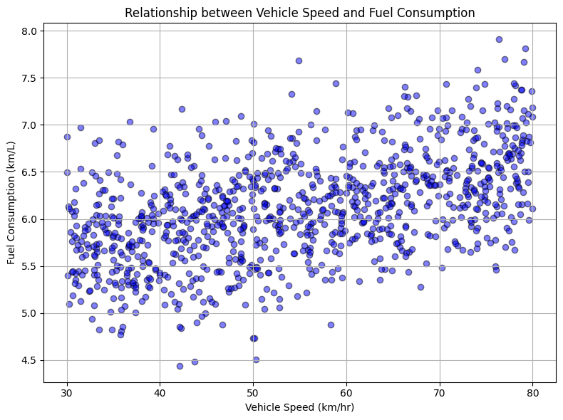

The line graph demonstrates the correlation between temperature and battery energy usage in hybrid cars, indicating that as temperature increases, battery energy consumption typically decreases. This visualization effectively showcases the influence of environmental factors on energy efficiency and underscores the significance of temperature management in optimizing battery lifespan and overall energy consumption in hybrid vehicles.

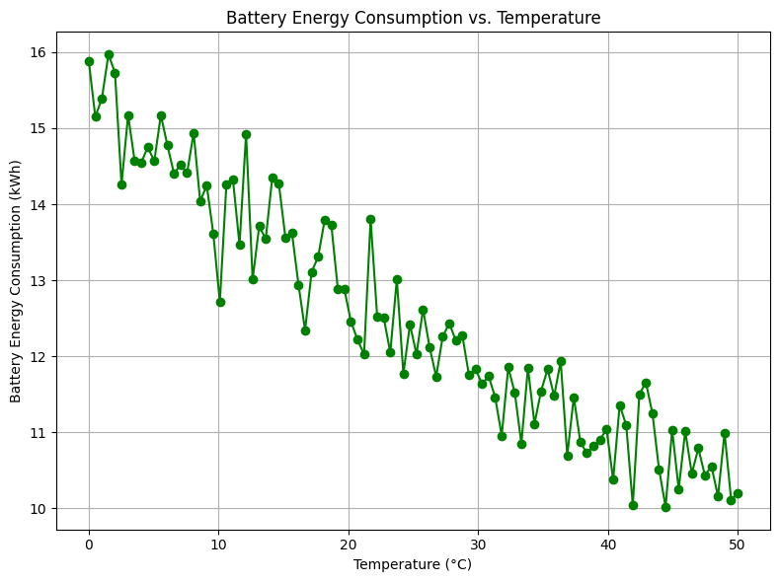

The bar graph compares the average fuel consumption of hybrid cars between urban and highway driving scenarios. Each bar represents the average fuel consumption for a specific driving situation, enabling a straightforward visual comparison of urban and highway conditions. This visualization aids in identifying the factors influencing energy efficiency in hybrid cars by offering valuable insights into the variations in fuel usage across different driving conditions.

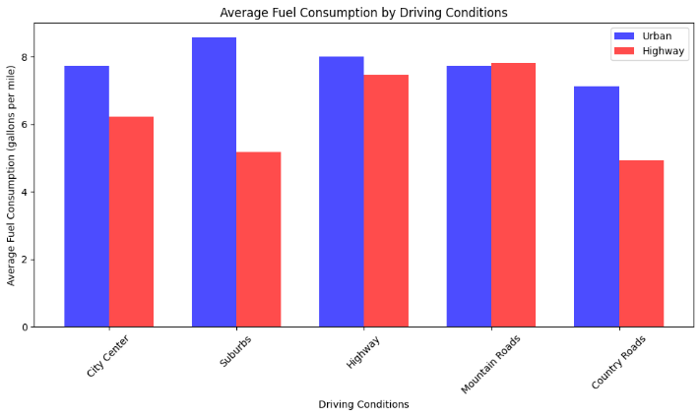

The research findings underscore the effectiveness of Model Predictive Control with Reinforcement Learning (MPC+RL) in optimizing energy efficiency in hybrid vehicles, demonstrating superior accuracy compared to alternative algorithms. Examination of driving conditions revealed diverse fuel consumption patterns across urban, highway, and various terrain types, emphasizing the necessity for customized energy management strategies. Sensitivity analysis on temperature highlighted the impact of temperature fluctuations on battery energy consumption, suggesting opportunities for temperature management to enhance energy efficiency. Additionally, the correlation between vehicle speed and fuel consumption elucidated by the scatter plot underscores the significance of speed optimization for achieving energy savings. Thorough model validation ensures the precision and reliability of developed methodologies, establishing a strong basis for practical implementation in real-world scenarios. In conclusion, the study's findings offer valuable insights for the development of intelligent energy management systems, the creation of energy-efficient hybrid cars, and the advocacy for legislative measures supporting environmentally friendly transportation methods.

1. ***Conclusion***

To sum up, this study contributes significant insights into the integration of Model Predictive Control and Reinforcement Learning (MPC+RL) to enhance the energy efficiency of hybrid cars. Through comprehensive analysis, the study demonstrates the superior accuracy of MPC+RL in optimizing energy management strategies compared to other algorithms. By investigating the impacts of temperature variations and driving conditions on energy consumption, the study underscores the importance of tailored strategies for efficient energy utilization. Additionally, the correlation between fuel usage and vehicle speed underscores the crucial role of speed management in reducing energy consumption. The study ensures the reliability and applicability of proposed methodologies in real-world settings through rigorous model validation. Overall, the findings offer practical guidance for the development of sustainable transportation solutions, promotion of eco-friendly vehicle practices, and advancement of energy-efficient transportation technologies.

1. ***Future Scope***

The findings from this study pave the way for future investigations aimed at enhancing energy efficiency in hybrid cars. One potential research direction involves exploring advanced algorithmic techniques, such as deep learning and reinforcement learning, to refine energy management systems and optimize real-time energy usage. Additionally, studies could delve into the integration of hybrid cars with smart grid systems, examining their role in incorporating renewable energy sources and ensuring grid stability. Another area of interest is adaptive energy management strategies that dynamically adjust to changing conditions and user preferences. Furthermore, integrating hybrid cars with emerging technologies like connected vehicles and autonomous driving has the potential to unlock new opportunities for system efficiency and energy optimization. Lastly, comprehensive lifecycle assessments are essential for informing policy development and decision-making processes regarding sustainable transportation, enabling a thorough analysis of the environmental impact and sustainability of energy management systems and hybrid cars.

1. ***References:***

[1] Neural Network and Efficiency-based Control for Dual-Mode Hybrid Electric Vehicles. QI Yunlong, WANG Weida, XIANG Changle

[2] An Approach to Enhance the Efficiency and Consumer Acceptability of a Series Plug-in Hybrid Vehicle. Christopher Rowe & Ilteris Demirkiran. Derek Bonderczuk & Patrick Currier.

[3] Energy Efficiency Improvement with Hydraulic Electric Hybrid Vehicles Hsiu-Ying Hwang,Tian-Syung Lan, and Jia-Shiun Chen.

[4] Analysis of the Performances of the Hybrid Lithium HE-HP Architecture For Plug-In Hybrid Electric Vehicles. Noshin Omar, Karel Fleurbaey , Can Kurtulus.

[5] Comparative study of hybrid electric vehicle and conventional vehicle under New European Driving Cycle and Bangkok Driving Cycle.Charadsuksawat A. and Laoonual Y.

[6] Efficiency Improvement of Electric and Hybrid Vehicles by Better Utilization of Inertia. Ventsislav Keseev

[7] Influence On Motor Size and Efficiency on Acceleration, Fuel Economy and Emissions of Split- Parallel Hybrid Electric Vehicles. Saiful A. Zulkifli, Syaifuddin Mohd, Nordin Saad.

[8] Efficiency-based control strategy of dual-mode hybrid vehicle. Xiang Changle; Qi Yunlong; Han Lijin.

[9] Improvement of battery charging efficiency using 2-clutch system for parallel hybrid electric vehicle. Minseok Song; Seokhwan Choi; Gyeonghwi Min.